**VIT Modern Application Development (Java SpringBoot) 2023**

NAME: Alan Shaji

REG. NO.: 20BRS1024

**ASSIGNMENT 1**

**QUESTION:**

Create one form with input and apply css to it.

**SOLUTION:**

**HTML code:**

<!DOCTYPE html>

<html>

<head>

<link rel="stylesheet" href="style.css"/>

</head>

<body>

<h1>

<center>

LOGIN

</center>

</h1>

<form method="post">

<table>

<tr><br>

<td>

<label for="name">Name: </label>

</td>

<td>

<input id="name" type="text" name="name" placeholder="Enter Name" required/>

</td>

</tr>

<tr>

<td>

<label for="email">Email: </label>

</td>

<td>

<input id="email" type="text" name="email" placeholder="Enter mail address" required/>

</td>

</tr>

<tr><br></tr>

<tr>

<td>

<button type="submit">Login</button>

</td>

</tr>

</table>

</form>

</body>

</html>

**CSS:**

h1{

font-size:40px;

font-family:Arial black;

font-weight:600;

line-height:1.5;

text-align:center;

background-color: beige;

}

body{

background-color: beige;

font-family:Arial black;

font-weight:100;

line-height:1.5;

}

input[type=text]{

width: 100%;

padding: 12px 20px;

margin: 8px 2px;

display: inline-block;

border: 2px solid #ccc;

box-sizing:content-box;

}

button {

background-color:forestgreen;

color: white;

padding: 10px 20px;

margin: 8px 0;

border: none;

cursor: pointer;

width: 100%;

}

button:hover{

opacity: 0.8;

}

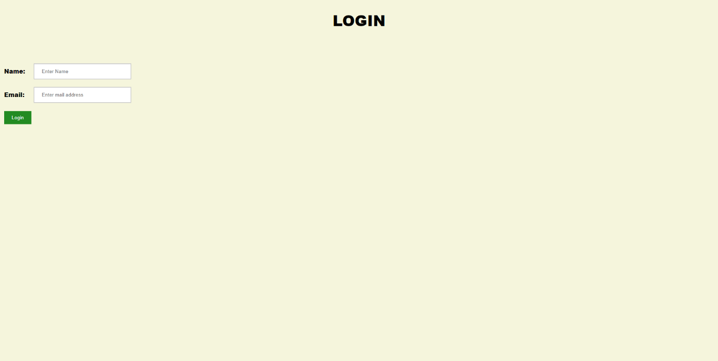**OUTPUT:**

